For this year's quarter 2 extra credit opportunity -- the "Kaiser Christmas Extra Credit Opportunity" -- you must watch 2 of the following 3 movies. Correctly answering any mixture of 10 questions you choose on the upcoming 'test' about the movies will earn you 5 points added to your quarter 2 test total. Only the indicated versions of the following movies are acceptable. Be sure to watch the movies closely, both for detail and overall message/theme.
The extra credit test dates will be prior to our mid-term exam and will be on: Dec 8 and Dec. 9.
(1983)
(1946) 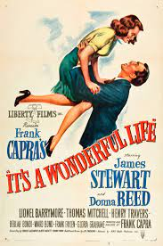
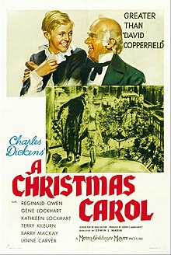 (1938)

